# Segment 5: SQL Tasks

* Add a new column named avg_rcv_amt in the table customers which contains the average receive amount for every country. Display all columns from the customer table along with the avg_rcv_amt column in the last.

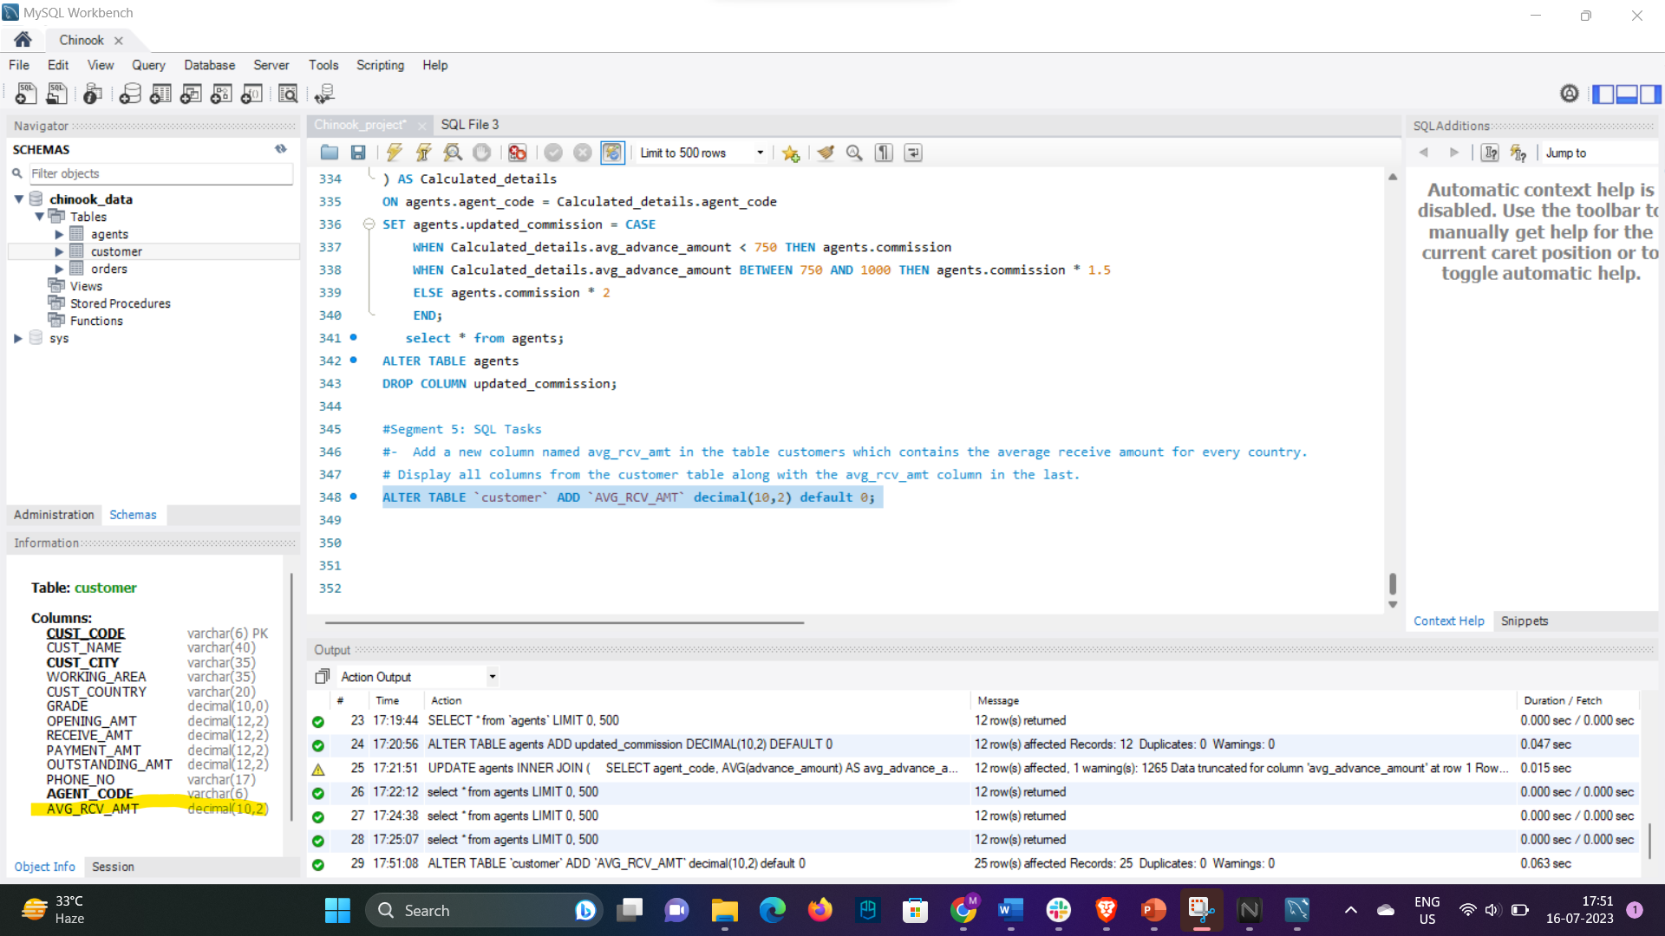

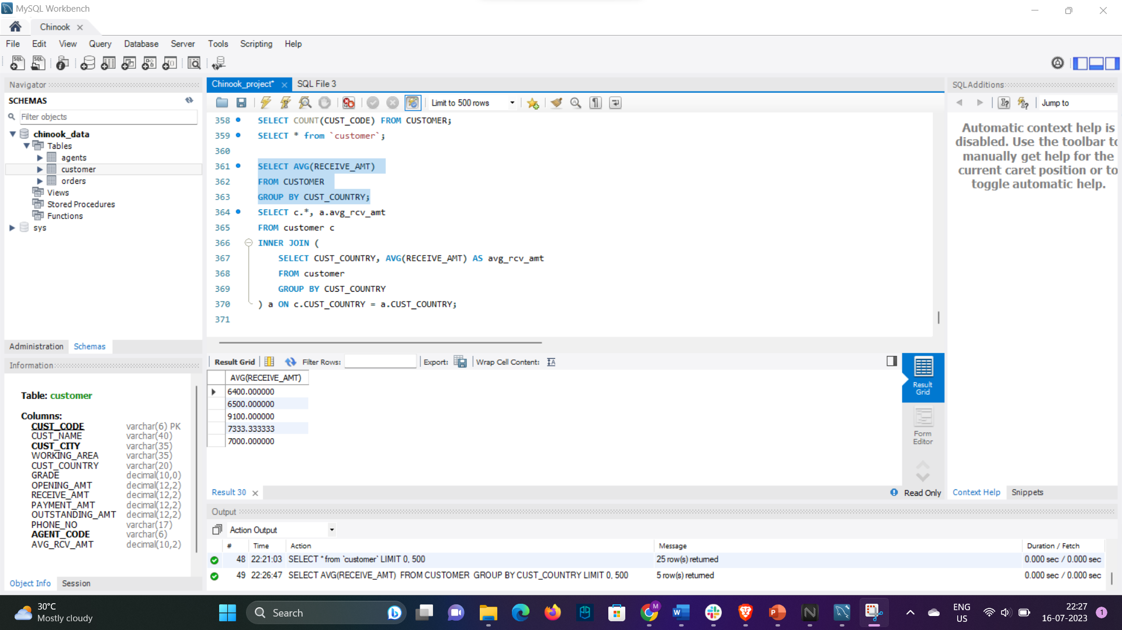

* Write a sql query to create and call a UDF named avg_amt to return the average outstanding amount of the customers which are managed by a given agent. Also, call the UDF with the agent name ‘Mukesh’.